April 25, 2018

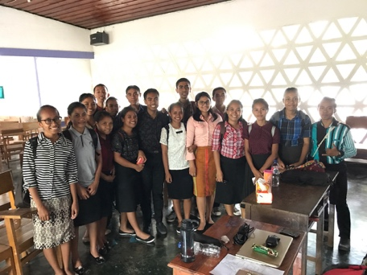
Opening Thoughts: Sometimes plans come together quickly and other times they take longer to develop. That’s what happened with this upcoming trip to Indonesia. Communication progressed over several months, but the final details came together in a span of 24 hours. Flights, accommodations, teaching responsibilities, and other connections fell right into place. It is amazing to see how the Lord worked it all out.
I am thrilled to return to Artha Wacana Christian University and work with emerging leaders. When the schedule clicked into place, the topic God’s Wisdom for Pastoral Ministry was heartily affirmed. Using themes from the Old Testament Wisdom Literature, the students will be encouraged to consider God’s Word as the primary source for their pastoral work of counsel, guidance, comfort, prayer, administration and community building. These five wisdom books offer a rich resource into God’s purpose for one’s spiritual growth and development.
Trip to Timor
April 26-28: Fly from Ithaca to Detroit- Japan- Singapore- Jakarta-Kupang
April 29- meet with people at the SIL Guest House and connect with University leaders in Kupang
April 30 – Be available for student and faculty interaction -at University
May 1-3 - Teach on God’s Wisdom for Pastoral Ministry during 100-minute teaching sessions Tuesday, Wednesday and Thursday
May 4-5 Additional student and faculty interaction
May 5 - Leave Kupang at 14:20 - arrive in Singapore at 23:30
May 6 - Meet and worship with Ithaca friends in Singapore
May 7 - 8 - Leave Singapore at 5:45am and return to Ithaca through Japan, and Detroit. Arrive in Ithaca at 5:10 pm on Tuesday

Trip Prayer Requests
Ask the Lord to prepare the hearts of the University students as we study insights for Pastoral Ministry from Job, Psalms, Proverbs, Ecclesiastes and Song of Songs.

Pray for the ministry of Artha Wacana Christian University as they prepare emerging leaders for the Timorese Church.
Also, pray for the Theological Faculty as they face the College’s reaccreditation process.

Pray for God’s strength for Dave to handle the various segments of travel and for good health throughout the trip.

Pray for Joyce as she remains in Ithaca during these days.

Pray for the conversations with the University faculty, as well as the Language and Cultural Centre, that will determine ministry opportunities in September.

Pray that these days will encourage this new generation of students to see how the God’s eternal Word addresses the issues that individuals and communities face. Pray that they will grab hold of the biblical truths for nurture and discipleship in the locales where they serve the Lord. Thanks for investing in these young leaders and many others around the world. Joyce and I are grateful for your loving support. Thank you!
Haiti in July with Givingall
At a New Jersey diner, in early February 2017, I began a conversation with the Givingall organization to partner with their pastoral training outreach in Arniquet, Haiti. Craig Coughlin (pictured in the center) is a high school teacher who responded to Haiti’s 2010 devastating earthquake by forming Givingall. Initially seeking to provide medical care, summer camps for children, and complete building projects, their vision expanded to include pastoral training in 2015. Last year, fifty-two pastors attended a training conference.

My role in July is to be part of the teaching staff, as well as share insights with the organization as it forms a five-year plan for training pastors. Rick DeFilippo (pictured on the right) is on the Givingall Board of Directors and participated in the last two training sessions. Forty years ago, Joyce and I met Rick at West Congregational Church in Peabody, MA, where he was a high schooler in the youth ministry Please begin to pray that the details and preparation for the upcoming July 20 -28 trip will come together smoothly. To learn more about Givingall, go to givingall.org.

